**Kissaki-Kai Karate-Do**



**France**



#### Kissaki-Kai Autumn Camp with the Meiyo Béziers Karate Club

#### 21 & 22 September 2019

**Event Schedule**

*Friday 20th September*

- 18:00h: BBQ at [1 Chemin de la Ceriseraie, La Caumette, 34600 Faugères](https://www.google.com/maps/place/Maison+de+Ma%C3%AEtre/@43.5839539,3.1629273,17z/data=!3m1!4b1!4m5!3m4!1s0x12b17744d6aa7393:0xd2f36e2bfba5e9cf!8m2!3d43.58395!4d3.165116)

*Saturday 21st September*

- 10.00h-15.00h: Training

[Halle de sports Lucie Aubrac, 171 avenue Georges Clémenceau, 34500 Béziers](https://www.google.com/maps/place/Meiyo+Beziers+Karate+Trot+Gerard/@43.3517776,3.2201808,17z/data=!4m8!1m2!2m1!1sHalle+de+sports+Lucie+Aubrac,+171+avenue+Georges+Cl%C3%A9menceau,+34500+B%C3%A9ziers!3m4!1s0x12b10e634a531e2b:0x18fa362f0bcced4a!8m2!3d43.3515902!4d3.2220679)

- 19.00h : dinner at Pizzypasta, [310 Avenue Ingarrigues, 34490 Lignan Sur Orb](https://www.google.com/maps/place/310+Avenue+Ingarrigues,+34490+Lignan-sur-Orb,+Frankrijk/@43.3792815,3.172659,17z/data=!3m1!4b1!4m5!3m4!1s0x12b10bf45af92643:0x3e22cb36a5787f63!8m2!3d43.3792776!4d3.1748477)

*Sunday 22nd September*

- 10.00h-15.00h: Training

[Halle de sports Lucie Aubrac, 171 avenue Georges Clémenceau, 34500 Béziers](https://www.google.com/maps/place/Meiyo+Beziers+Karate+Trot+Gerard/@43.3517776,3.2201808,17z/data=!4m8!1m2!2m1!1sHalle+de+sports+Lucie+Aubrac,+171+avenue+Georges+Cl%C3%A9menceau,+34500+B%C3%A9ziers!3m4!1s0x12b10e634a531e2b:0x18fa362f0bcced4a!8m2!3d43.3515902!4d3.2220679)

**Prices**

Training only: €40 Kissaki-Kai members, €50 non-members

BBQ Friday evening: €10

Having a car is a ‘must’ to get around!

**Booking**

To reserve your space please return the form below with payment. Should you have to cancel, you will receive a full refund up to 1 week prior to arrival.

Payment via Paypal to: [seminars@kissaki-kai.com](mailto:seminars@kissaki-kai.com) or via bank transfer in € to:

Peter ou Eva Morris, Crédit Agricole Languedoc,

IBAN FR76 1350 6100 0085 1331 4116 804, AGRIFRPP835

Valuing the Original Purpose of Martial Arts

**Kissaki-Kai France**

1 Chemin de la Ceriseraie

La Caumette, 34600 Faugères

France

[**vincemorris@kissaki-kai.com**](mailto:vincemorris@kissaki-kai.com)

[**eva@kissaki-kai.com**](mailto:eva@kissaki-kai.com)

We uphold the values and principles of the original purpose of the martial arts; to empower members with the ability to defend themselves, their families and the weak, and to foster the development of steadfastness, courage and integrity.

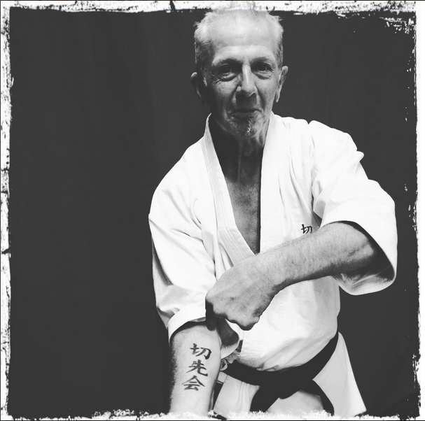

**Kissaki-Kai Karate-Do**

**France**



**Contact details**

- For general questions and to reserve your spot: [eva@kissaki-kai.com](mailto:eva@kissaki-kai.com)

Mobile: 0033 (0) 6 44 81 00 02

- For training and grading questions: [vincemorris@kissaki-kai.com](mailto:vincemorris@kissaki-kai.com)

‘- Local contact / registration without accommodation:

Sensei Nathalie Trotin (Meiyo Béziers Karate) Tel : +33 (0)6 86 97 84 28

**Accommodation**

- self-catering accommodation in La Caumette on request. Other nearby options:

- self-catering : [Campotel, Boulevard Jean Moulin, 34600 Bédarieux](https://www.google.com/maps/place/Villages+Vacances+%C3%80+Bedarieux/@43.6131859,3.1529804,17z/data=!3m1!4b1!4m5!3m4!1s0x12b179c081a4269f:0xc69add0d237f4c2b!8m2!3d43.613182!4d3.1551691), +33 4 67 23 30 05

- [www.herault-tourisme.com](http://www.herault-tourisme.com)

- [Hotel de l'Orb, Parc Phoros, Route de Saint Pons, 34600 Bédarieux](https://www.google.com/search?q=Hotel+de+l%27Orb%2C+Parc+Phoros%2C+Route+de+Saint+Pons%2C+34600+B%C3%A9darieux&rlz=1C1GCEA_enBE828BE828&oq=Hotel+de+l%27Orb%2C+Parc+Phoros%2C+Route+de+Saint+Pons%2C+34600+B%C3%A9darieux&aqs=chrome..69i57.1315j0j4&sourceid=chrome&ie=UTF-8), +33 (0) 4 67 23 35 90

- <https://www.hotel-orb.com>

**Local airports by distance to Faugères**

Béziers (35 mins), Montpellier (1hr), Carcassonne (1.5hrs), Perpignan (2hrs), Toulouse (2.5hrs), Barcelona (3hrs)

Please do not forget to send us your flight details / ETAs once you have them.

We uphold the values and principles of the original purpose of the martial arts; to empower members with the ability to defend themselves, their families and the weak, and to foster the development of steadfastness, courage and integrity.



Valuing the Original Purpose of Martial Arts

**Kissaki-Kai Karate-Do**

**France**



Registration Form for the

Kissaki-Kai Autumn Camp in France with the

Meiyo Béziers Karate Club

21 and 22 Sept 2019

Name(s) + Address:

_______________________________________________________________________________________

_______________________________________________________________________________________

_______________________________________________________________________________________

_______________________________________________________________________________________

_______________________________________________________________________________________

_______________________________________________________________________________________

Contact details (mobile phone, e-mail):

_______________________________________________________________________________________

_______________________________________________________________________________________

_______________________________________________________________________________________

_______________________________________________________________________________________

_______________________________________________________________________________________

_______________________________________________________________________________________

N° of persons attending seminar only: ______

N° of persons for BBQ: ______

N° of persons for dinner at PizzyPasta: ______

Arrival date: ____________________________ Departure date: ____________________________

Special requirements, comments etc.:

_______________________________________________________________________________________

_______________________________________________________________________________________

_______________________________________________________________________________________

_______________________________________________________________________________________

_______________________________________________________________________________________

_______________________________________________________________________________________

_______________________________________________________________________________________

_______________________________________________________________________________________

_______________________________________________________________________________________